UNITED STATES

SECURITIES AND EXCHANGE COMMISSION

Washington, D.C. 20549

FORM 8-K

CURRENT REPORT

Pursuant to Section 13 or 15(d) of the Securities Exchange Act of 1934

Date of Report (Date of earliest event reported): June 1, 2026

NextCure, Inc.

(Exact name of registrant as specified in its charter)

Delaware | 001-38905 | 47-5231247
(State or other jurisdiction of incorporation) | (Commission File Number) | (IRS Employer Identification No.)
9000 Virginia Manor Road, Suite 200
Beltsville, Maryland |  | 20705
(Address of principal |  | (Zip Code)
executive offices)

Registrant's telephone number, including area code: (240) 399-4900

(Former name or former address, if changed since last report.)

Check the appropriate box below if the Form 8-K filing is intended to simultaneously satisfy the filing obligation of the registrant under any of the following provisions:

- Written communications pursuant to Rule 425 under the Securities Act (17 CFR 230.425)

- Soliciting material pursuant to Rule 14a-12 under the Exchange Act (17 CFR 240.14a-12)

- Pre-commencement communications pursuant to Rule 14d-2(b) under the Exchange Act (17 CFR 240.14d-2(b))

- Pre-commencement communications pursuant to Rule 13e-4(c) under the Exchange Act (17 CFR 240.13e-4(c)) Securities registered pursuant to Section 12(b) of the Act:
Title of each class | Trading Symbol(s) | Name of each exchange on which registered
Common Stock, $0.001 par value per share | NXTC | Nasdaq Global Select Market

Indicate by check mark whether the registrant is an emerging growth company as defined in Rule 405 of the Securities Act of 1933 (§230.405 of this chapter) or Rule 12b-2 of the Securities Exchange Act of 1934 (§240.12b-2 of this chapter). Emerging growth company ☐

If an emerging growth company, indicate by check mark if the registrant has elected not to use the extended transition period for complying with any new or revised financial accounting standards provided pursuant to Section 13(a) of the Exchange Act. ☐

Item 7.01 Regulation FD Disclosure

On June 1, 2026, NextCure, Inc. (“Company”) issued a press release announcing the presentation of a poster containing Phase 1 dose escalation data for its investigational drug candidate SIM0505, such presentation occurring at the American Society for Clinical Oncology 2026 conference (“ASCO 2026”) in Chicago, IL, on June 1, 2026.

A copy of the Company press release is furnished as Exhibit 99.1 to this Current Report on Form 8-K, and a copy of the ASCO 2026 poster is furnished as Exhibit 99.2 to this Current Report on Form 8-K.

On June 1, 2026, Company updated its corporate presentation to reflect pipeline updates and interim phase 1 data from its ongoing clinical trial for SIM0505. Beginning on June 1, 2026, Company will be engaging with members of the investment community, which may reference these presentation materials.

A copy of the Company presentation materials is furnished as Exhibit 99.3 to this Current Report on Form 8-K.

The information contained in this Item 7.01, including Exhibits 99.1, 99.2, and 99.3, shall not be deemed to be “filed” for purposes of Section 18 of the Securities Exchange Act of 1934, as amended (the “Exchange Act”), or otherwise subject to the liabilities of that section, nor shall it be deemed incorporated by reference into any of the Company’s filings under the Exchange Act or the Securities Act, regardless of any general incorporation language in such filing.

Item 8.01 Other Events

On June 1, 2026, Company announced data from its Phase 1 dose escalation study (NCT06792552) evaluating SIM0505 in a multicenter, first in human global study in patients with advanced solid tumors. The reported data were from 59 cancer patients applying a data cutoff of April 07, 2026. Patients in the U.S. (n=25) and China (n=34) received SIM0505 at doses ranging from 1.6 mg/kg to 9.6 mg/kg and were enrolled without preselection for CDH6 expression.

SIM0505 efficacy data for gynecologic cancer patients (consisting of ovarian cancer patients and uterine serous carcinoma (“USC”) patients) in dose cohorts in the range of 4.8 – 8.0 mg/kg and who have had a minimum 12 weeks of follow-up as of the April 7, 2026 data cut off (n=20) are reported in the table below. All percentages reflect objective response rate (“ORR”) as determined using best response according to RECIST v1.1 criteria.


Patient Group | ORR*
All gynecologic patients (n=20) | 55% (11/20)
• Ovarian cancer (n=17) | 52.9% (9/17)
• USC (n=3) | 66.7% (2/3)
*Reported for patients within therapeutic SIM0505 dose cohorts of 4.8 - 8.0 mg/kg who had a minimum 12 weeks of follow-up at the April 7, 2026 data cut-off, and were determined by best response according to RECIST 1.1 criteria. Of the nine (9) ovarian patients with PR, there was one unconfirmed PR and one PR pending confirmation at next follow-up scan.

SIM0505 safety data for all patients (n=59) were as follows. No primary prophylaxis for hematological toxicities was used. The observed Grade 1 and Grade 2 treatment emergent adverse events (“TEAEs”) were predominantly hematological, nausea and vomiting. TEAEs leading to dose reduction (n=12) were predominantly hematological (4.8 – 9.6 mg/kg) and the majority occurring at 8.0 mg/kg, with nonhematological events including fatigue, dyspnoea, and nausea/vomiting (n=1 each). Observed Grade 3 and 4 TEAEs were predominantly hematological and manageable without primary prophylaxis for hematological toxicities. Treatment related adverse events (“TRAEs”) requiring dose discontinuation (n=3) were Grade 2 interstitial lung disease (“ILD”) and Grade 3 fungal pneumonia (both at 6.4 mg/kg), and Grade 4 thrombocytopenia (at 9.6 mg/kg). Adverse Events of Special Interest (“AESI”) were pneumonitis (n=1, Grade 1 at 5.6 mg/kg), and ILD (n=1, Grade 2 at 6.4 mg/kg).

Patient demographics data for all patients (n=59) were as reported in the table below:

 | All Patients
Baseline Characteristics | (n=59)
Age, years: median (range) | 58 (42-78)
Sex, %: Male/Female | 3.4%/96.6%
Race, n (%)
Asian | 34 | (57.6%)
Black or African American | 3 | (5.1%)
White | 20 | (33.9%)
Other | 2 | (3.4%)
Tumor Type, n (%)
Ovarian | 46 | (78.0%)
USC/other endometrial | 10 | (16.9%)
Renal cell carcinoma (RCC) | 3 | (5.1%)
ECOG performance status, n (%)
0 | 16 | (27.1%)
1 | 43 | (72.9%)
Prior systemic anti-cancer regimen: median (range) | 5 (1-12)

On June 1, 2026, Company announced that it believes that its existing cash, cash equivalents and marketable securities will be sufficient to fund its planned operations into the first quarter of 2027. Company based this estimate on assumptions that may prove to be incorrect, and it could exhaust its available capital resources sooner than it currently expects.

Item 9.01 |  | Financial Statements and Exhibits
(d) Exhibits
Exhibit No. |  | Description
99.1 |  | Press Release issued by NextCure, Inc. dated June 1, 2026
99.2 |  | ASCO 2026 Poster dated June 1, 2026
99.3 |  | NextCure, Inc. Presentation dated June 1, 2026
104 |  | Cover Page Interactive Data File (formatted as inline XBRL).

SIGNATURE

Pursuant to the requirements of the Securities Exchange Act of 1934, the registrant has duly caused this report to be signed on its behalf by the undersigned hereunto duly authorized.

Dated: June 1, 2026 | NEXTCURE, INC.
 | By: | /s/ Steven P. Cobourn
 | Name: | Steven P. Cobourn
 | Title: | Chief Financial Officer


Exhibit 99.1

NextCure Presents Positive SIM0505 Phase 1 Dose Escalation Data in Patients with Gynecologic Cancers at ASCO

2026

– 55% ORR in gynecologic cancers with 52.9% in ovarian and 66.7% in USC at 12 weeks by best response per RECIST 1.1 within the therapeutic dose range (4.8 – 8.0 mg/kg)
– Favorable safety and tolerability in heavily pretreated population supports ongoing Phase 1 dose-optimization with emphasis on PROC

– NextCure to host virtual Key Opinion Leader (KOL) Event June 2, 2026 at 8 AM ET

BELTSVILLE, MD – June 1, 2026 (GLOBE NEWSWIRE) – NextCure, Inc. (Nasdaq: NXTC), a clinical-stage biopharmaceutical company committed to discovering and developing novel therapies to treat cancer, and Simcere Zaiming Pharmaceutical Co., Ltd., (Simcere Zaiming) an oncology-focused biopharmaceutical company and a subsidiary of Simcere Pharmaceutical Group Ltd (HKEX: 2096), today announced the presentation of positive Phase 1 dose escalation data for SIM0505 at the American Society for Clinical Oncology (ASCO 2026) in Chicago, IL (poster #246). SIM0505 is an investigational antibody drug conjugate (ADC) targeting Cadherin-6 (CDH6) with a proprietary topoisomerase 1 inhibitor (TOPOi) payload. NextCure plans to host a virtual KOL Event on Tuesday, June 2, 2026 (register here) to review these data.

Platinum-resistant ovarian cancer (PROC) and uterine serous carcinoma (USC) represent two of the most challenging gynecologic malignancies. In PROC, once platinum resistance develops, response rates to available therapies drop to as low as 10–25%, with a median overall survival of approximately 11 months. USC, while accounting for only 10% of uterine cancers, is responsible for about 40% of uterine cancer deaths, with 5-year survival falling to 33% in advanced-stage disease. Taken together, these two cancers represent a persistent and significant unmet need for more effective treatment options.¹⁻³

The Phase 1 dose escalation study (NCT06792552) evaluated SIM0505 in 59 heavily pre-treated cancer patients, with a data cutoff of April 07, 2026. Patients in the U.S. (n=25) and China (n=34) received SIM0505 at doses ranging from 1.6 mg/kg to 9.6 mg/kg, regardless of CDH6 expression.

Positive efficacy data were observed, with an objective response rate (ORR) of:

- 55% (11/20) for gynecologic cancers (ovarian cancer and USC)

- 52.9% (9/17) for ovarian cancer

- 66.7% (2/3) for USC

- Responses were observed across a range of CDH6 expression

ORRs, above, are reported for patients within therapeutic dose cohorts of 4.8 – 8.0 mg/kg who had a minimum 12 weeks of follow-up at the data cut-off, and were determined by best response according to RECIST 1.1 criteria. Of the nine (9) ovarian patients with partial response (PR), there was one unconfirmed PR and one PR pending confirmation at next follow-up scan.

“Positive Phase 1 data presented at ASCO 2026 validate our conviction in SIM0505 as a potential best-in-class CDH6-directed therapy for gynecologic cancers. Meaningful response rates at 12 weeks, alongside a manageable safety profile, give us strong confidence in this program and reinforce our enthusiasm for the ongoing dose optimization study. We believe SIM0505 has broad potential in gynecologic cancers and beyond, and these data put us on a solid track toward pivotal studies and our goal of bringing this treatment to patients," said Michael Richman, President and CEO of NextCure.

“Data presented at ASCO 2026 underscore the promise of our ADC platform and SIM0505, purpose-designed to deliver better efficacy, safety and tolerability, combining a carefully selected EC1 CDH6 epitope with our proprietary CPT116 topoisomerase payload. These results validate the science behind the SIM0505 construct and the accelerating pace of the global development program. Together with our partner, we remain deeply committed to advancing innovative medicines for patients facing hard-to-treat cancers,” said Renhong Tang, PhD, CEO of Simcere Zaiming.

“Treatment of gynecologic cancers has advanced meaningfully in recent years, yet the need for safer and more effective treatments remains real. CDH6 is an attractive target given its expression across ovarian, uterine, and other solid tumors. ADCs directed at this target have the potential to deliver the deeper, more durable responses these patients need. The early response rates observed for SIM0505 at ASCO 2026 are encouraging, and I believe the safety profile is manageable in routine clinical practice. I am enthusiastic about this program and its potential to advance the standard of care in gynecologic cancers,” said Udayan Guha, MD, PhD, Chief Medical Officer of NextCure.

ASCO Poster Overview: “Phase 1, multicenter, first-in-human (FIH) global study of SIM0505, an anti-CDH6 (CDH6) antibody-drug-conjugate (ADC) in patients with advanced solid tumors”

Table 1: Study Subject Overview:

 | All Patients
Baseline Characteristics | (n=59)
Age, years: median (range) | 58 (42-78)
Sex, %: Male/Female | 3.4%/96.6%
Race, n (%)
Asian | 34 | (57.6%)
Black or African American | 3 | (5.1%)
White | 20 | (33.9%)
Other | 2 | (3.4%)
Tumor Type, n (%)
Ovarian | 46 | (78.0%)
USC/other endometrial | 10 | (16.9%)
Renal cell carcinoma (RCC) | 3 | (5.1%)
ECOG performance status, n (%)
0 | 16 | (27.1%)
1 | 43 | (72.9%)
Prior systemic anti-cancer regimen: median (range) | 5 (1-12)

Table 2: Efficacy Overview:


Patient Group | ORR*
All gynecologic patients (n=20) | 55% (11/20)
• Ovarian cancer (n=17) | 52.9% (9/17)
• USC (n=3) | 66.7% (2/3)
*Reported for patients within therapeutic SIM0505 dose cohorts of 4.8 - 8.0 mg/kg who had a minimum 12 weeks of follow-up at the April 7, 2026 data cut-off, and were determined by best response according to RECIST 1.1 criteria. Of the nine (9) ovarian patients with PR, there was one unconfirmed PR and one PR pending confirmation at next follow-up scan.

Overall safety: Favorable overall data, potentially manageable in routine practice setting (n=59):

- Grade 1 and 2 treatment emergent adverse events (TEAEs) predominantly hematological, nausea and vomiting

- Grade 3 and 4 TEAEs predominantly hematological and manageable without primary prophylaxis for hematological toxicities

- Treatment related adverse events (TRAEs) requiring dose discontinuation: n=3

A full copy of the poster will be available on the NextCure website under the Investor Relations “Events & Presentations” tab following the presentation.

Virtual KOL Event

NextCure will host a virtual KOL Event to discuss the ASCO 2026 data.

- Date: June 2, 2026

- Time: 8:00 AM ET

- Registration Link: Click here

A replay of the webinar will be accessible on the Events page of the NextCure website for 90 days.

About SIM0505

SIM0505 is a novel ADC directed to CDH6, featuring a proprietary TOPOi payload. The ADC is designed for broad anti-tumor activity, fast systemic clearance and an improved potential therapeutic window. SIM0505 is being evaluated in an open-label, Phase 1 study (NCT06792552) for the potential treatment of advanced solid tumors, including ovarian cancer, with an emphasis on PROC. The U.S. Food and Drug Administration granted Fast Track Designation to SIM0505 for the treatment of PROC. NextCure holds exclusive global rights for SIM0505, excluding China, Hong Kong, Macau, and Taiwan which are retained by Simcere Zaiming.

About the Phase 1 Trial of SIM0505

SIM0505 is being evaluated in a global Phase 1 open-label, multicenter study (NCT06792552) with sites in the U.S. and China. The Phase 1 dose escalation segment has evaluated SIM0505, at dose levels from 1.6 mg/kg to 9.6 mg/kg, in heavily pre-treated cancer patients with solid tumors including gynecologic cancers and renal cell carcinoma. As of the April 7, 2026 data cutoff, 59 patients were enrolled without preselection for CDH6 expression. Follow-up is ongoing.

In May 2026, NextCure initiated a Phase 1 dose optimization segment in gynecologic cancers, initially focusing on patients with PROC. The global study is expected to enroll up to 120 patients, with initial doses of 5.6, 6.4 and 7.2 mg/kg, at sites in the U.S., Canada, the EU and China.

About Ovarian Cancer⁴⁻⁸

Ovarian cancer is the fifth leading cause of cancer-related death among women. It is characterized by vague, easily overlooked symptoms like bloating, pelvic pain, and frequent urination that often go undetected until late stage. Risk factors include age, family history, BRCA1/2 mutations, and hormone therapy use. The median age at diagnosis is 63, and the overall 5-year relative survival rate is 51.6% — though early-stage diagnosis carries a 5-year survival rate of 91.7%. As of 2022, an estimated 244,000 women were living with ovarian cancer in the United States.

About Uterine Serous Cancer²

Uterine serous carcinoma is a rare but highly aggressive subtype of endometrial cancer, accounting for approximately 10% of uterine cancers and about 40% of uterine cancer deaths. It typically arises in postmenopausal women, with abnormal or postmenopausal bleeding as the most common presenting symptom. Risk factors include advancing age, a history of breast cancer, tamoxifen use, and hereditary breast-ovarian cancer syndrome. More than half of patients present with stage III or IV disease at diagnosis, contributing to its disproportionate mortality burden.

About NextCure, Inc.

NextCure is a clinical-stage biopharmaceutical company focused on advancing innovative medicines to treat cancer patients through the use of targeted therapies including antibody-drug conjugates. We focus on advancing therapies that leverage our core strengths in understanding biological pathways and biomarkers, the interactions of cells within and beyond the tumor microenvironment, and the role each interaction plays in a biologic response.

About Simcere Zaiming

Simcere Zaiming is an oncology-focused biopharmaceutical company and a subsidiary of Simcere Pharmaceutical Group Limited (HKEX: 2096, "Simcere"). Founded in 2023, Simcere Zaiming is dedicated to developing groundbreaking therapies to address the unmet clinical needs of cancer patients globally. With a robust and innovative R&D pipeline featuring distinct clinical assets, Simcere Zaiming has successfully launched several innovative products in China, including COSELA®, Enweida®, Endostar®, and Enlituo®. The company is determined to deliver potentially transformative treatment options to cancer patients worldwide through its internal R&D, manufacturing, and commercialization capabilities, complemented by strategic collaborations with leading partners.

Sources:

- Based on Lheureux S, Braunstein M, Oza AM. CA Cancer J Clin. 2019;69(4):280–304. PMID: 31099893, DOI: 10.3322/caac.21559

- Based on Ferriss JS, Erickson BK, Shih IM, Fader AN. Int J Gynecol Cancer. 2021;31(8):1165–1174. PMID: 34210768, DOI:

10.1136/ijgc-2021-002753

- Based on Hamilton CA, Cheung MK, Osann K, et al. Br J Cancer. 2006;94(5):642–646. PMID: 16495918, DOI: 10.1038/sj.bjc.6603012

- Based on Cabarca S, Ili C, Vanegas C, Gil L, Vertel-Morrinson M, Brebi P. Drug resistance biomarkers in ovarian cancer: a bibliometric

study from 2017 to 2022. Front Oncol. 2024 Nov 11;14:1450675. doi: 10.3389/fonc.2024.1450675. PMID: 39588300; PMCID: PMC11586235.

- National Cancer Institute SEER Program

- Ovarian Cancer Research Alliance (OCRA)

- American Cancer Society

- American Cancer Society / NCI SEER

All trademarks are the property of their respective owners.

Forward-Looking Statements

Some of the statements contained in this press release are forward-looking statements within the meaning of the Private Securities Litigation Reform Act of 1995, including with respect to funding for our operations, our expected cash runway, objectives and expectations for our business, operations and financial performance and condition, including the progress and results of clinical trials, development plans and upcoming milestones regarding our therapies. Any statements contained herein that are not statements of historical fact may be deemed to be forward-looking statements. In some cases, you can identify forward-looking statements by terminology such as “aim”, “anticipate”, “assume”, “believe”, “continue”, “could”, “should”, “due”, “estimate”, “expect”, “intend”, “hope”, “may”, “objective”, “plan”, “predict”, “potential”, “positioned”, “seek”, “target”, “towards”, “forward”, “later”, “will”, “would”, and other similar expressions that are predictions of or indicate future events and future trends, or the negative of these terms or similar language.

Forward-looking statements involve substantial risks and uncertainties that could cause actual results to differ materially from those projected in any forward-looking statement. Such risks and uncertainties include, among others: our expectations regarding the timing, progress and results of preclinical studies and clinical trials for SIM0505, LNCB74 and any other product candidates we develop; our estimates regarding our expenses, future revenues, capital requirements, needs for or ability to obtain additional financing and the period over which we expect our current cash, cash equivalents and marketable securities to be sufficient to fund our operations, market and other conditions; the timing or likelihood of regulatory filings for SIM0505, LNCB74 and any other product candidates we develop and our ability to obtain and maintain regulatory approvals for such product candidates for any indication; the identification, analysis and use of biomarkers and biomarker data; our drug product sourcing and manufacturing strategy, including the scalability of our methods and processes; our expectations regarding the potential benefits, activity, effectiveness and safety of SIM0505, LNCB74 and any other product candidates we develop; our intentions and ability to successfully commercialize, including through partnering, our product candidates; our expectations regarding the nature of the biological pathways we are targeting; our expectations regarding our ability to discover and advance product candidates using our technologies; the potential benefits of and our ability to maintain our relationship with LigaChem Biosciences, Inc., Simcere Zaiming Pharmaceutical Co., Ltd., and other third-party vendors and collaborators; our ability to retain key personnel; our intended reliance on and the performance of third parties, including collaborators, contract research organizations and third-party manufacturers; changes in international relations, tariffs, and other trade regulations between the U.S. and China; our ability to protect and enforce our intellectual property protection and the scope and duration of such protection; developments and

projections relating to our competitors and our industry, including competing therapies; and the impact of current and future laws and regulations.

More detailed information on these and additional factors that could affect NextCure’s actual results are described under the heading “Risk Factors” in NextCure’s most recent Annual Report on Form 10-K and 10-Q and in NextCure’s other filings with the Securities and Exchange Commission. You should not place undue reliance on any forward-looking statements. Forward-looking statements speak only as of the date of this press release, and NextCure assumes no obligation to update any forward-looking statements, even if expectations change.

Investor Inquiries

Timothy Mayer, PhD

NextCure, Inc.

Chief Operating Officer

- 762-6486

IR@nextcure.com

Mike Moyer

Managing Director,

LifeSci Advisors, LLC

Phone: (617) 308-4306

mmoyer@lifesciadvisors.com

Exhibit 99.2
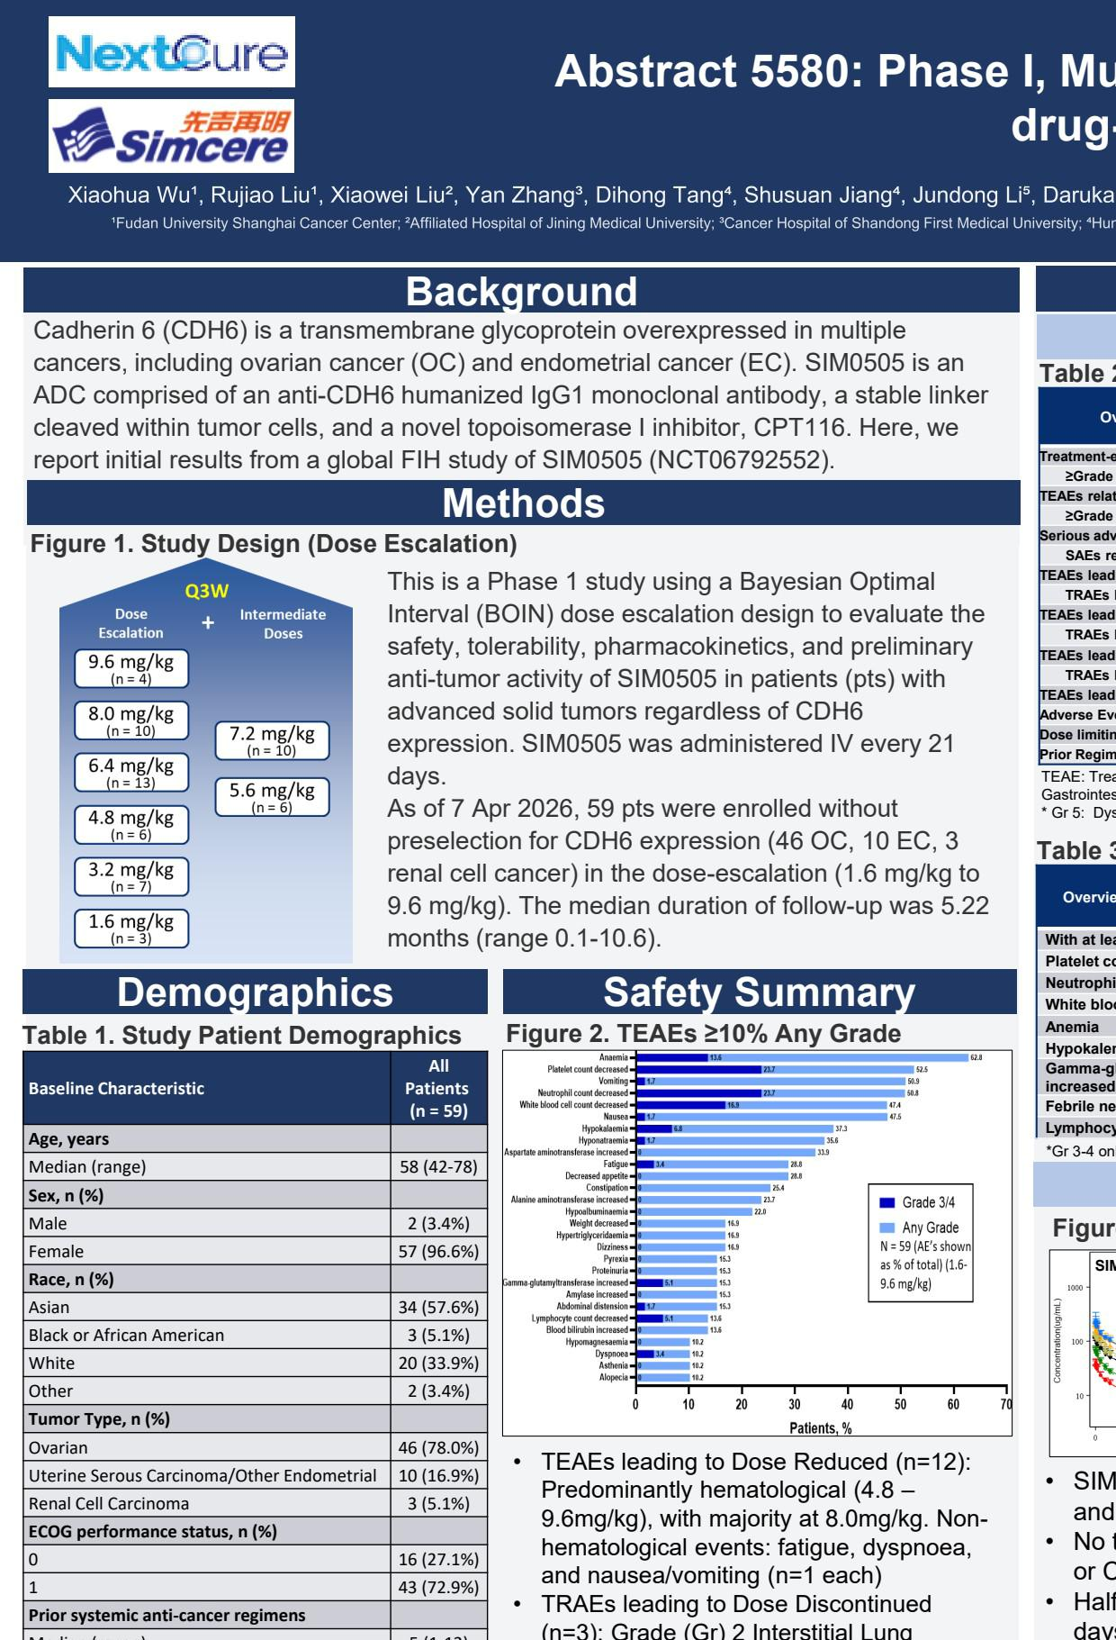

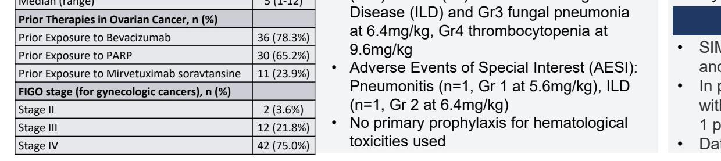

Exhibit 99.3




